**Revenue Operation Analyst**

Fidel Chan

The report is focused on analyzing the different breakdowns of our leads acquired from 2020 to identify opportunities or problems we might be currently facing, so that we can offer a set of recommendations. The breakdowns mentioned above consist of separating the leads by the sector of the company (Retail, Media, Apps, etc.), the current status of the lead (converted or rejected), the source from which the lead originated (Consumer Website or Paid ads), the size of the converted deal and the month in which the lead was created.

**Anomalies** identified within this report include, the submission of the same identifier appearing multiple times across the data and the leads originated from the following sectors: Financial Services, Health Care, Media, Legal and Software (We will discuss this later on). In order to offset this discrepancies, I’ve decided to remove all of the identifiers that appears multiple times within the dataset (Due to lack of context of why there are duplicates of identifiers) and decided to create two groups of leads the Anomalous Sector (All leads that came from the sectors previously mentioned) and the Non-Anomalous Sector(All leads that came from the remaining sectors).

**Key Points** we can obtain from the data are the following:

* We had a total of 45,282 new leads created on 2020, which can be dissected into the following groups:

|  |  |  |  |  |  |
| --- | --- | --- | --- | --- | --- |
|  |  | Percentage of Total Leads | | MoM Converted Growth Rate  (Feb - April) | |
|  | Total Leads | Converted | Rejected |
| Anomalous Sector | 25,861 | 52% | 38% | 0% | |
| Non Anomalous Sector | 19,421 | 30% | 38% | -2.7% | |
| Total | 45,282 | 43% | 39% | -2.1% | |

It is important to note that for the past 3 months we have experienced a negative growth, which is a decline in the number of leads we are converting on a monthly basis, furthermore the rejection rate of our Non Anomalous group is 8% greater than the converted rate; accentuating the negative growth rate. (Further recommendation will be discuss in the Anomalous section within the doc)

* The **Non Anomalous sectors** that generate most of our converted deals are the following: **Apps, Commerce and Shopping, Artificial Intelligence, Data and Analytics and Biotechnology.** However, there might be **potential in the Media and Entertainment sector** since 75% of their leads have deal sizes between 2,300 and 4,600 approximately, which its distribution ranges between higher numbers when compared to the other sectors.
* The **top performing lead source** among the Non-Anomalous Sector is **Consumer Website which the converted rate was 7% greater than the Paid Ads source**, it is recommended to invest more on the Consumer Website and improve the analytics within the website to track the user experience that prospective customers have.

# Anomalous Sector

The sectors belonging to this group have experienced either an astounding number of rejections or conversions. Meanwhile the other sectors seem to follow a trend as shown in the scatter plot below.

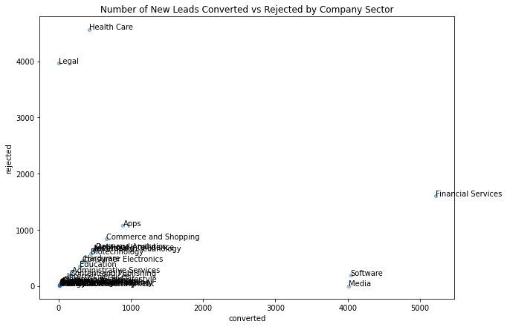

It's really palpable the anomalies seen through the scatterplot. We can even pinpoint that leads belonging to the following sectors Financial Services, Health Care, Media, Legal and Software have experienced this exceptional behavior. This could be a typo error from one of our agents or it could definitely be our “power users sectors”. For the moment, it’s impossible either to define this as an error among our system or not, without more information around the assignee in charge of the populating this data or more granular information about the company appended to the lead.

# Deal Size distribution by Non-Anomalous Sector

By building a box plot, we can visualize the distribution of each sector and understand how a specific sector compares to the rest. This is built to identify new opportunities that might be overshadowed by the presence of bigger sectors.

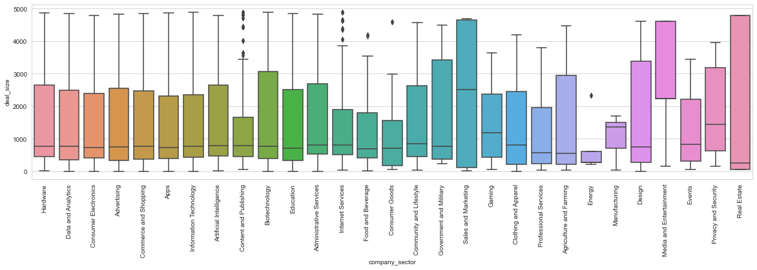

Though we have to zoom in the image, we can see that the Media and Entertainment box is condescended and located further up than the rest of the boxes shown in the graph. This means, without going into much detail, that 75% of the leads have between 2,300 and 4,600 deals, approximately.

# Consumer Website vs Paid Ads Source (Non-Anomalous Sector)

After identifying what were our top sectors; Apps (With 14% of the total deals belonging to this sector), Commerce and Shopping (11%), Artificial Intelligence (9%), Data and Analytics (9%) and Biotechnology (8%). I wanted to see from what source did most of the leads come from and compare the number of Converted vs Rejected Leads. What the data showed is that on average the conversation rate of Consumer Websites was 7% higher than the Paid Ads. The images shown on the next page is a visualization proof about the metric mentioned in the previous sentence.

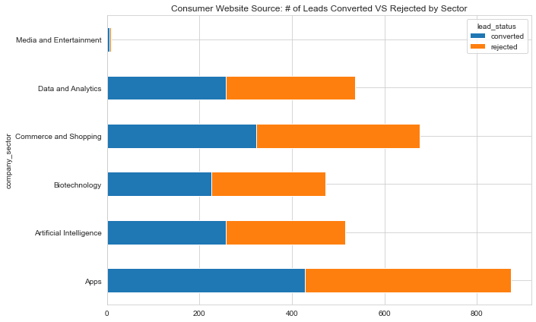

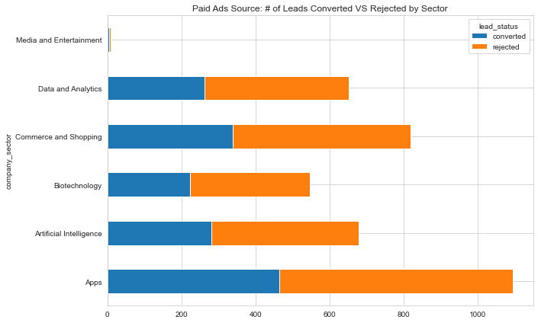

# Final Recommendations

* Track Information around the assignee of the one in charge of updating the respective lead status, that way we can understand why the Anomalous Sectors have peculiar metrics and understand the performance of our agents.
* Track Retention Rate of the consumers by the lead source, even though a lead source might generate a conversion that doesn’t necessarily mean it is good at retaining consumers.
* Track Name of the Company, since we might treat differently certain leads that are coming from the same Company as those that aren’t. Or if only one Company can have at most one lead that could be a great way to track bugs.
* Track User Events of our Consumer Website, it would be interesting to see if our users are engaging with the webpage and if so understand where is the dropoff of those that got rejected or rejected the product.